Art Mural Analysis
“Can public art promote public health?” This question was thoroughly explored in a Yale evaluation of the Porch Light Program (Tebes & Matlin, 2015). The program creates public murals designed to transform neighborhoods while promoting the well-being of both residents and those involved in the mural’s creation (Tebes & Matlin, 2015).
PART 1
The mural that stood out to me the most as a newer addition in the community and one I was eager to learn more about is Better Together. It can be found across from the Market Square Garage in downtown Knoxville. This 80-foot mural is located at 500 W Summit Hill Dr SW, Knoxville, TN 37902.
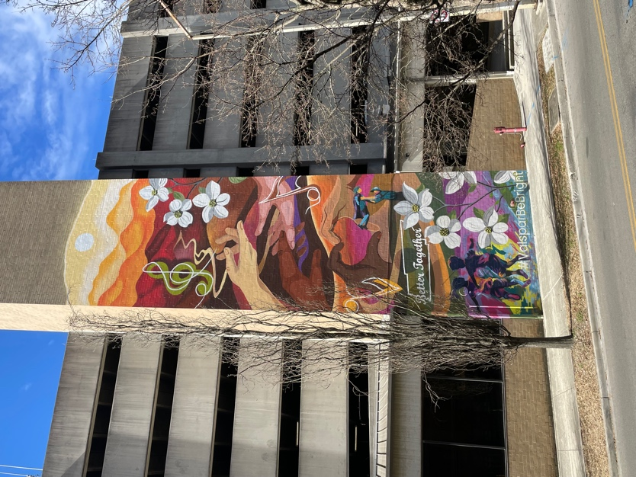
Better Together #ValsparBeBright Artist: Kadavien Baylor
Here are a few other murals that caught my eye and left an impression as I explored the stunning artwork throughout downtown Knoxville.
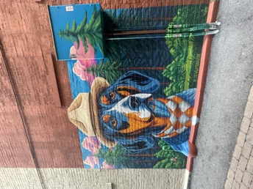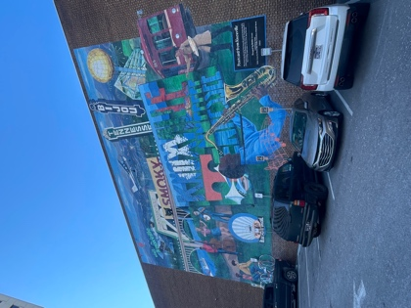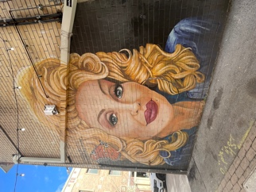
PART 2
I selected downtown Knoxville to explore murals because it is the part of the city that I live nearby and cherish the most. It is what I consider to be my local community and in a way was a deeper self-reflection to see how the murals in my zip code affect me as well as the community that I interact with the most. Downtown is also the part of the city that many visitors will more likely explore than any other part of Knoxville. I wanted to see how the murals may affect a tourist’s ideas of our city and regional culture. The Smokey dog and Dolly murals were simply beautiful and iconic features for any East Tennessean to appreciate. The middle image is located on the side of the visitor center in downtown Knoxville and is called Postcard from Knoxville. I have always loved this piece but have never stopped to look deeper into everything it represents. According to Visit Knoxville, this piece was created to honor the artists, musicians, and visionaries that make Knoxville a great place to live as well as travel(visitknoxville.com).
The mural that I did choose, Better Together, was inspired in celebration of a local named Peter Malnati and his professional golf accomplishments. Valspar paint has created an initiative called Be Bright where they work with local artists to create murals for communities. The goal of the mural was to highlight how the Knoxville community is better together. In an interview by WVLT, Malnati stated, “everybody in life, we’re after the same things, we’re after a sense of belonging, we’re after a sense of meaning. If we can seek those things together, try to find the things that unite us rather than the things that divide us, we’ll be much better off as a community and as a society (Morgan-Rumsey, 2024).” The mural depicts iconic features of East Tennessee such as the Smoky Mountains, Dogwood flowers, the Tennessee River, and music notes. Also depicted are hands, which represent the diversity of Knoxville, reaching towards one another, facing up and open which generally means truth, peace, or honesty, and another pair connecting to make a heart. Towards the bottom right of the mural, Malnati himself is pictured holding his son up in the air after he won his golf championship. The son appears to be wearing a cape which could represent many things such as family, Malnati supporting his kids dreams, or perhaps even his son viewing him as his superhero or role model. At the very bottom left of the mural are children playing which represent having fun or simply appreciating youth. The colors are bright and bold which I found cheerful and pleasing to look at.
Better Together was created by the mural artist Kadavien Baylor who says his focus is to use public art to educate communities on the beauty of human existence. Baylor creates art aimed at fostering self-awareness and social understanding. He challenges traditional human and artistic values, using art as a powerful communication tool shaped by modern aesthetics and design (K. B., 2024).
The mural Better Together reflects multiple aspects of health such as social and environmental health. The phrase Better Together suggests a strong sense of community and connection. The depiction of hands reaching toward one another and people engaging in movement highlights the importance of relationships, support, and collective well-being. Social connections have been shown to reduce stress, improve mental health, and even boost physical health. Environmental health is also well represented in this mural by the inclusion of flowers and natural elements. This emphasizes the connection between human health and the environment. Access to green spaces and nature is linked to lower stress levels and improved overall well-being. The artwork visually reinforces the importance of maintaining a healthy and beautiful environment.
PART 3 & 4
“Neighborhood and built environment is a social determinant of health, or a nonmedical factor that impacts the health and well-being of children, youth, and families (CDCP, 2023).” By incorporating natural regional elements such as dogwood flowers, the Smoky Mountains, and the Tennessee River, the mural emphasizes the importance of a healthy physical environment. Access to green spaces and aesthetically pleasing surroundings are linked to improved mental health and increased physical activity. The 2023 Abridged Community Health Assessment for Knox County emphasizes the role of the built environment in influencing health outcomes, noting that well-maintained public spaces encourage outdoor activities and community engagement (Abridged, 2023).
The mural’s focus on unity and connection encompasses the SDoH of social and community context. A community’s social health, such as belonging, is strongly linked to mental health. People who feel like they are part of a community have lower rates of mental health problems. When individuals feel mentally well, they are more inclined to participate in social activities, offer support to others, and engage in volunteer work. This strengthens community bonds and enhances overall quality of life (Effects of community, 2024). According to the Knox County Mental Health Report 2023, Tennessee ranks 46th (of 51) for mental health workforce availability, which means a severe lack of resources and staff available to aid (Abridged, 2023). Murals are powerful because they can help mental health in a way that is accessible to people in a community across all walks of life. Better Together reflects diversity and community values that help people feel more connected. It along with many other murals in the area transformed dull locations into bright and inviting environments. Public murals also inspire people to walk, explore, and engage with their surroundings.
In exploring the murals of downtown Knoxville, I gained a deeper understanding of how public art shapes both personal and community identity. The murals I encountered, particularly Better Together, not only highlight the cultural and environmental beauty of East Tennessee but also serve as powerful tools for fostering social connection and well-being. Public art can transform spaces, inspire engagement, and promote mental health by creating inviting, uplifting environments. Better Together exemplifies this through its vivid imagery, themes of unity, and emphasis on belonging. In a city where mental health resources are limited, murals provide an accessible and meaningful way to support well-being, strengthening both individuals and the community. I have come to appreciate how deeply murals contribute to Knoxville’s identity, creating a sense of place for both residents and visitors alike.

References
Abridged Community Health Assessment. Knox County Tennessee Health Department. (2023). https://www.knoxcounty.org/health/pdfs/CHA_2023.pdf
Centers for Disease Control and Prevention. (2023, March 27). Neighborhood and built environment. Centers for Disease Control and Prevention. https://www.cdc.gov/prepyourhealth/discussionguides/neighborhood.htm
Effects of community on Mental Health. Recovery Team. (2024, May 7). https://recoveryteamnewton.com/blog/treatment/effects-of-community-on-mental-health/
K. B. (2024). Kadavien Baylor (@kadavien). Culturalyst. https://culturalyst.com/kadavien
Morgan-Rumsey, C. (2024, October 31). Market square garage mural honors Knoxville Golf Champion. https://www.wvlt.tv. https://www.wvlt.tv/2024/10/31/market-square-garage-mural-honors-knoxville-golf-champion/
Tebes, J. K., & Matlin, S. L. (2015). Porch Light Program: Final Evaluation Report. https://dbhids.org/wp-content/uploads/2016/01/Community_Mural-Arts_Porch-Light-Evaluation.pdf

